Earthquake Tracker Lab Assignment

A Hands-On Dive into Working with Remote, Live, Distributed Earthquake Data using C++

Image was AI generated with ChatGPT in June 2025.

Required Skills & Knowledge

- Strings
- Loops
- Functions
- Makefiles
- Basic JSON
- Remote, Distributed Data

Assignment Objective
- You will be able to develop and implement an algorithmic solution for interacting with a remote service.
- You will practice working with data in JSON format.
- You will be able to compile and run programs using a Makefile.
THIS IS NOT A TYPICAL LAB ASSIGNMENT! The purpose of this assignment isn’t just to practice writing code containing functions, loops, and strings in C++. The primary purpose of this assignment is to introduce you to the concept of accessing distributed, remote data from your programs and to practice by finishing a basic program that accesses real, live data.

Assignment Description
Your first job in this assignment is to complete a C++ program that will:
- read data from a live, remote United States Geological Survey (USGS) earthquake data repository,
- filter the given data, and
- display the data to the screen in the specified way.
Then, answer questions in this document about the lab and submit the answers along with your solution.

Remote, Distributed, LIVE Data
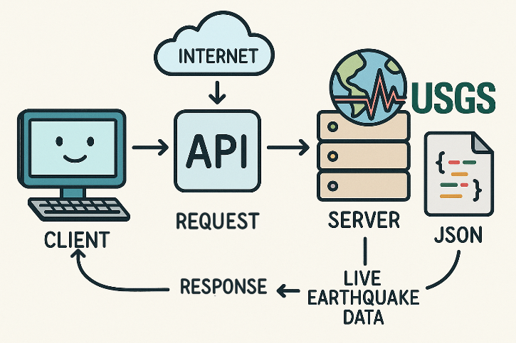
When you need data from a remote source (the server), you use that source’s Application Programming Interface (API) to request the data.
Your computer (the client) uses the API over the network (internet), the server accesses the data and sends it back in a way you can use.
  - The API acts as a messenger between you and the system that stores the data.
  - In many cases, the data isn’t stored in just one place—it might be spread across multiple locations like different servers or databases.
  - However, you don’t need to worry about that because the API handles that part.

In this assignment, you will be retrieving data from a remote source (USGS Earthquake data) and the data will be returned in JSON format. This data is LIVE, which means it is constantly updated in real time!

JSON Format
JSON text format is very readable by both humans and computers. Below is an image of a JSON object. JSON objects contain key-value pairs. For example, the key “place” has value “Volcano Islands, Japan region”.
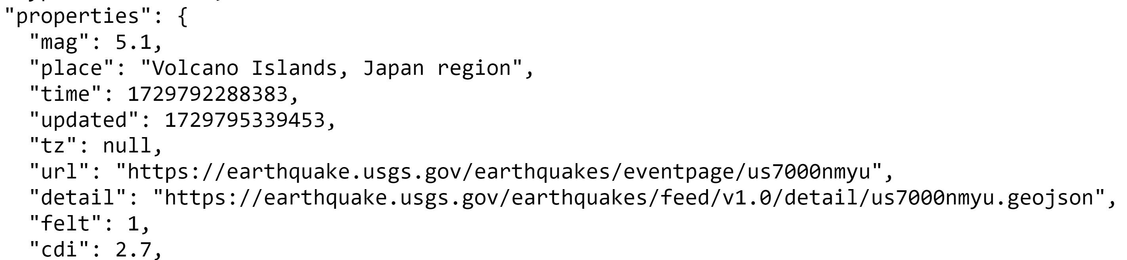

Paired Programming Option
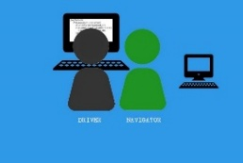
You may complete this lab assignment alone or you have an OPTION to complete this lab with a lab partner using paired programming techniques discussed in previous labs. Make sure each partner uploads the same exact zip file to your Lab 8 assignment in ilearn. Each source file should have both of your names in the comment block at the top. Both students will receive the same feedback and grade.

Detailed INSTRUCTIONS

REQUIRED SET-UP
- Use your Lab8 folder for this assignment.
- Download the following files from ilearn:
  - Earthquake Lab Given Files.zip
  - Makefile Lecture Slides and Example

- Extract the given files in your Lab8 folder. Your Lab8 folder should contain the following files:
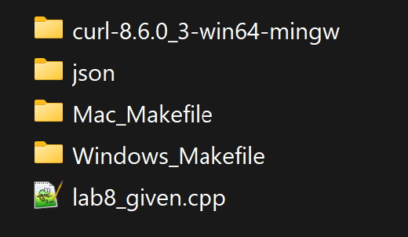
  - curl-8.6.0_3-win65-mingw
  - json
  - Mac_Makefile
  - Windows_Makefile
  - lab8_given.cpp
- Next, rename lab8_given.cpp to lab8.cpp.
- Next, copy the correct Makefile to your Lab8 directory.
  - if you have a Mac, you need to copy the Makefile from the Mac_Makefile folder and place directly under your Lab8 folder.
  - If you have a Windows laptop, copy the Makefile from the Windows_Makefile folder and place directly under your Lab8 folder.
- Copy the file named libcurl-x64.dll that is inside the curl-8.6.0_3-win64-mingw folder and paste it directly inside the Lab8 folder.

See the screen capture below that shows what the Lab8 folder will look like after you have done all these steps. If you do not have the same folders in your Lab8 directory, you have missed a step!
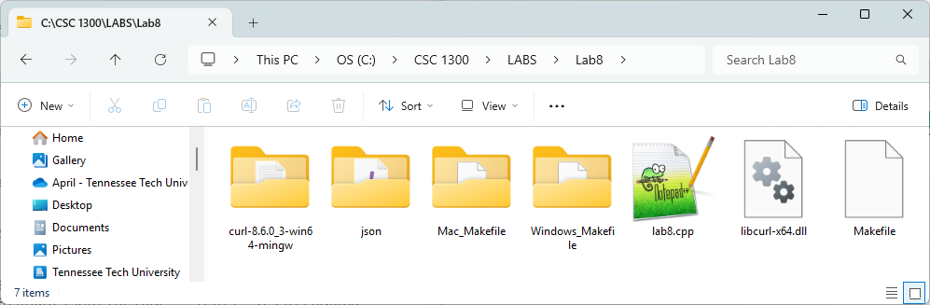

FINISH THE PROGRAM CODE
- Look at the JSON file that you will be accessing with your code. This will help you understand the code already written for you and aid in adding to the program The URL is https://earthquake.usgs.gov/earthquakes/feed/v1.0/summary/all_month.geojson.
- Add these new #includes
  - #include <curl/curl.h>
This open source library is required to use cURL. CURL is used to transfer data specified with URL syntax, which you will need in this program since you are accessing and transferring data from an HTML page.
More information: https://curl.se/
  - #include <nlohmann/json.hpp>
The data you will be accessing is in JSON format, which is why you need this library to be able to access and read the data with your program. The JSON for Modern C++ library was created by Mr. Lohmann and is available at https://github.com/nlohmann. This library is provided for you in the given files.
  - #include <sstream>
In this program, you are going to use the ostringstream class from the sstream library to temporarily store data that you download from a website. Just like you used ofstream to write to a file, you’re using ostringstream to write to a string variable in memory.
More information: https://cplusplus.com/reference/sstream/ostringstream/
  - In the main function of your source code there is a function call to downloadDataFromURL() where the argument is a string URL. You need to change the string to the URL “https://earthquake.usgs.gov/earthquakes/feed/v1.0/summary/all_month.geojson” (make sure the string contains the double quotes). This is the URL of the website you are accessing.
- You should not modify any of the code in the downloadDataFromURL()function, but you may want to read through the function to see what it does. This function uses curl to transport the data from the website to your local machine and will store the data in an ostringstream variable called oss, which is then changed to a string and stored in a string variable that gets returned back to main and placed in a string variable named jsonString.
- The main function in this program contains C++ exception handling with keywords try and catch.
  - The try statement allows you to define a block of code to be tested for errors while it is being executed.
  - The catch statement allows you to define a block of code to be executed if an error occurs in the try block.
  - The catch statement in this program prints the exception (error) to the screen. If you can successfully read from the HTML file, your program should only execute the try block of code.
  - For more information on try & catch, visit https://www.w3schools.com/cpp/cpp_exceptions.asp
- A range-based for loop (foreach loop) is already given to you. Make sure that your loop matches the one given below. This is a type of loop only used with variables that contain multiple data pieces, such as our jsonObject string (and in Module 8 we use it with arrays & vectors). This loop iterates through (go through) each piece of data in the jsonObject string and stores the piece of data in “element”.
for (string element : jsonObject[“features”])
  - As mentioned before, JSON objects contain key-value pairs. Your job is to:
    - print the first 10 earthquakes that have a magnitude of 4.5 or higher
    - print the earthquakes that caused a tsunami
  - To help you with the syntax of the code, you are given the first foreach loop that prints the first 10 earthquakes that have a magnitude of 4.5 or higher. You will just need to add the other loop to complete the lab. The if statement in the first loop should look like:
if (element[“properties”][“mag”] >= 4.5)

COMPILING & RUNNING WITH THE MAKEFILE
- Update the file paths in your Makefile according to the directions for your operating system below.
- Look at section below on “FILE PATHS” if you are unsure what a file path is.
- Use the Makefile presentation slides and example provided to see how to compile in your command prompt/terminal with the make command and then to run the program with the make run command.
  - make: builds the executable file (equivalent to running your g++ statement)
  - make run: runs your executable file
  - make clean: removes the executable file from your directory

Windows
            - Make sure you are using the provided Windows version Makefile.
            - Open it with VS Code.
            - Copy the file path to your lab 8 program files.
              - To find your include path, navigate to your lab 8 directory in your File Explorer.
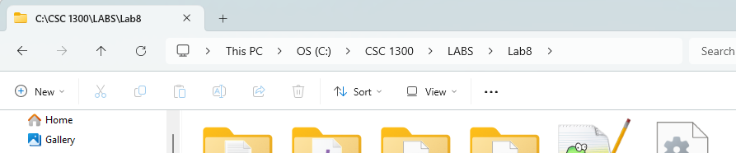
CLICK HERE
              - Then, highlight the bar at the top to find your include path
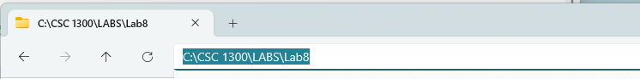

            - Change YOUR/PATH/HERE in THREE places on line 29.
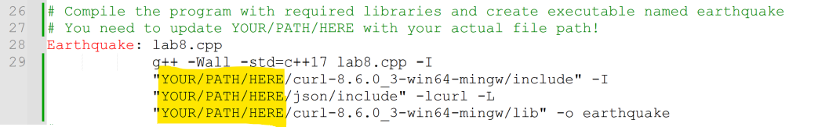
On my computer, I changed the filepath to this:
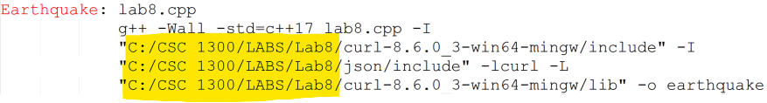
(your lab assignment folder may be in a different location on your computer)

Mac
            - Make sure you are using the provided Mac version Makefile.
            - Open it with VS Code.
            - Copy the file path to your lab 8 program files.
              - To find your file path, navigate to your Lab 8 directory in the terminal.
              - Then, type in the pwd command, which will return your path (remember, ls to display what is in your current directory and cd to navigate through the directories).
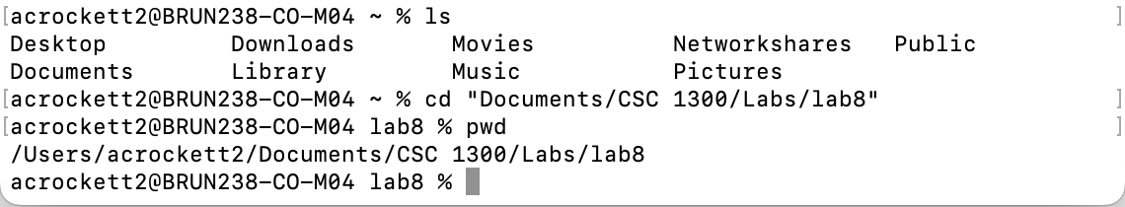
            - Change YOUR/PATH/HERE in TWO places on line 28.
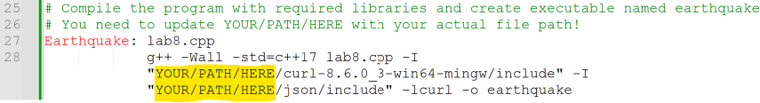

Sample Output
- There is no user input in this program.
- If you successfully retrieved the data and printed it on the screen, it should look similar to the sample below this when you run it.
- The data WILL be different since the data is live updated.

Earthquakes with magnitude greater than or equal to 4.5:

Earthquake 1:
Place: "139 km NW of Neiafu, Tonga"
Magnitude: 4.9
Earthquake 2:
Place: "145 km SSW of Severo-KurilΓÇÖsk, Russia"
Magnitude: 6.2
Earthquake 3:
Place: "Volcano Islands, Japan region"
Magnitude: 4.7
Earthquake 4:
Place: "West Chile Rise"
Magnitude: 5
Earthquake 5:
Place: "Izu Islands, Japan region"
Magnitude: 4.9
Earthquake 6:
Place: "5 km W of Cruz Grande, Mexico"
Magnitude: 4.9
Earthquake 7:
Place: "off the coast of Central America"
Magnitude: 4.6
Earthquake 8:
Place: "south of the Fiji Islands"
Magnitude: 5.5
Earthquake 9:
Place: "49 km SSW of Labuha, Indonesia"
Magnitude: 4.9
Earthquake 10:
Place: "56 km SSE of Kawalu, Indonesia"
Magnitude: 4.9

Earthquakes that caused a tsunami:

Earthquake 1:
Place: "235 km SE of Akutan, Alaska"
Magnitude: 5.3
Earthquake 2:
Place: "32 km W of Akhiok, Alaska"
Magnitude: 4.4
Earthquake 3:
Place: "175 km SW of Nikolski, Alaska"
Magnitude: 5
Earthquake 4:
Place: "5 km SE of Ontario, CA"
Magnitude: 3.99
Earthquake 5:
Place: "81 km SSW of Unalaska, Alaska"
Magnitude: 5.4
Earthquake 6:
Place: "125 km SE of Neiafu, Tonga"
Magnitude: 6.6
Earthquake 7:
Place: "3 km of Aromas, CA"
Magnitude: 4.15

AnsWER THESE QUESTIONS
Create a Word document named lab8_documentation.docx in your Lab8 folder and answer the following questions:

Question 1
Take a screenshot of your output when you run your program and paste it in your lab8_documentation.docx document.

Question 2
In this assignment you retrieved data from a remote source (USGS Earthquake data) at earthquake.usgs.gov/earthquakes/feed/v1.0/summary/all_month.geojson. This data is LIVE, which means it is constantly updated in real time, and it contains all detected earthquakes in the past month.
At the time of writing this part of the document on June 30, 2025, below is a screenshot of the data.
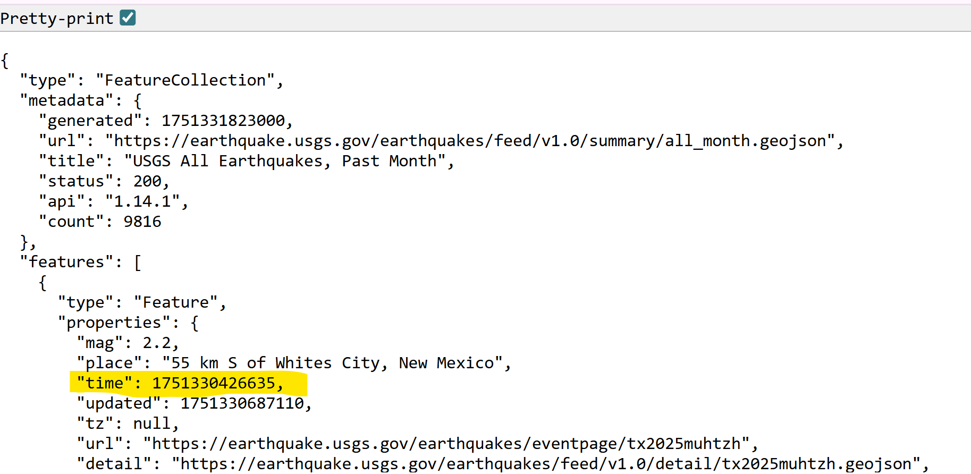
There were 9,816 earthquakes in the last month. Notice the first earthquake in the file had a timestamp (highlighted in yellow) of 1751330426635. This is a Unix timestamp in milliseconds since the Unix epoch (January 1, 1970, at 00:00:00 UTC). In other words, it has been 1,751,329,931.390 seconds since January 1, 1970, and if you convert this to a human-readable date, it is Monday, June 30, 2025, at 7:40PM US Central time zone.
- Go to this URL right now and take a screenshot of the first earthquake in the file similar to my screenshot below.
- Paste the screenshot in your lab8_documentation.docx file.
- Go to https://www.epochconverter.com/ and type in the Unix timestamp in milliseconds to convert it to a human-readable date in your time zone.
- Write the human-readable date in your lab8_documentation.docx file.

Question 3
In simple terms and in your own words, define the following:
- Remote Data
- Distributed Data
- API
- JSON

QUESTION 4
Describe a different real-world situation where a large amount of data must be retrieved from one or more remote servers to provide some type of public service. There are many correct answers for this question.

what to turn in
Create a zip file containing the following .cpp files and upload it to ilearn.
- Lab8.cpp
- Lab8_documentation.docx

Created by April Crockett (acrockett@tntech.edu), Senior Lecturer in Computer Science at Tennessee Technological University
https://www.tntech.edu/engineering/programs/csc/index.php
Work created with NSF award #2321015 “Collaborative Research: CyberTraining:Implementation:Medium: Modern Course Exemplars infused with Parallel and Distributed Computing for the Introductory Computing Course Sequence”
https://www.nsf.gov/awardsearch/showAward?AWD_ID=2321015
Last Updated 7/14/2025

